MOVEMENT IN THE PYROCENE: A GLOBAL META-ANALYSIS OF ANIMAL MOVEMENT RESPONSES TO FIRE

Supplementary Material

Supplementary Information 1: Literature search information
Web of Science Core Collection search string
"spatial ecology" OR biologg* OR "utilization distribution*" OR "site fidelity" OR movement* OR "home range*" OR "space use" OR "movement rate" OR "movement pattern*" OR "movement ecology" OR "animal movement" (All Fields) AND fire* OR burn* OR wildfire* OR bushfire* (All Fields)
Web of Science Core Collection filters
Article (Document Types) AND English (Languages) AND Ecology OR Environmental Sciences OR Zoology OR Multidisciplinary Sciences OR Biodiversity Conservation OR Forestry OR Biology OR Ornithology OR Evolutionary Biology OR Environmental Studies (Web of Science Categories)
Scopus search string
( TITLE-ABS-KEY ( "spatial ecology" OR biologg* OR "utilization distribution*" OR "site fidelity" OR movement* OR "home range*" OR "space use" OR "movement rate" OR "movement pattern*" OR "movement ecology" OR "animal movement" ) AND TITLE-ABS-KEY ( *fire * OR burn* OR wildfire* ) )
Scopus search filters
( LIMIT-TO ( DOCTYPE , "ar" ) ) AND ( LIMIT-TO ( SUBJAREA , "ENVI" ) OR LIMIT-TO ( SUBJAREA , "AGRI" ) OR LIMIT-TO ( SUBJAREA , "MULT" ) OR LIMIT-TO ( SUBJAREA , "VETE" ) ) AND ( LIMIT-TO ( LANGUAGE , "English" ) )
ProQuest Dissertation and Theses Global search string
noft(fire* OR burn* OR wildfire* OR bushfire*) AND noft("spatial ecology" OR biologg* OR "utilization distribution*" OR "site fidelity" OR movement* OR "home range*" OR "space use" OR "movement rate" OR "movement pattern*" OR "movement ecology" OR "animal movement")
ProQuest Dissertation and Theses Global filters
ecology OR forestry OR zoology OR wildlife conservation OR wildlife management OR environmental science OR biology OR climate change OR conservation biology OR animal sciences OR habitats OR environmental management OR natural resource management (Subject) AND English (Language)

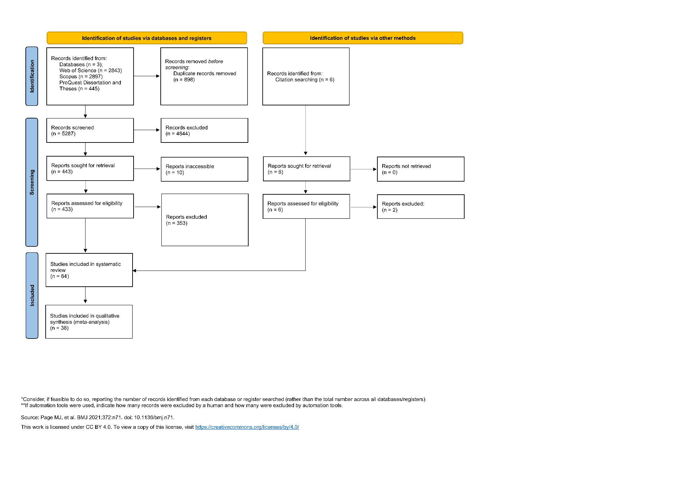
Figure S1.1: PRSIMA diagram (Page et al., 2021) depicting the identification and screening process for the systematic review and meta-analysis. The left-hand flow shows the records identified through database searches, and the right-hand flow shows records identified via searching the reference lists of review articles returned in the database searches.

Table S1.1: The variables extracted from original studies, external trait databases, and other sources used to summarise studies in the systematic review and as predictor variables in meta-analytical models.
Source | Variable | Description
Original Studies | Study Country | The country where the study occurred, extracted from the authors description.
 | Latitude and Longitude | The latitude and longitude of study site, either as provided by authors or determined by reviewers.
 | Study Species | The Latin name of study species, as provided by the authors. Names where later updated to current naming conventions by the reviewers if necessary.
 | Study Design | Categorisation of the study design (before-after, control-impact or before-after-control-impact), as determined by reviewers from the authors description of the study methods and presentation of results used to calculate effect sizes.
 | Movement Category | Reviewer’s classification of response measured as either (i) home range (areal estimate of home range size); (ii) distance (linear measurement of movements between points, including mean movement rates); (iii) tortuosity (measure of how convoluted a movement path is); or (iv) other measures of space use (non-areal measurements of movements within home ranges such as residency and proportion of area used).
 | Impact Fire Type | Categorisation of the type of impact fire/s (Wildfire, Planned, Both or Unclear), extracted based authors description of the fire/s. Extracted where provided.
 | Impact Fire Season | Categorisation of the season of the impact fire (Spring, Summer, Autumn or Winter) extracted based on dates or authors categorisation. Extracted where provided.
 | Impact Fire Characteristics | Authors qualitative description of treatment fire, such as frequency, severity, and intensity. Extracted where provided. Extracted where provided.
 | Impact Fire Size | The size of the impact fire as provided by the authors. Where the impact of multiple fires where evaluated, the size of individual fire extents where summed. Extracted where provided.
 | Maximum Treatment Age | The maximum time period between the treatment fire and data collection, as stated by authors or calculated by reviewers using information provided within the article. Extracted where provided.
 | Effect size information | Information used to calculate effect sizes, including sample size, mean, standard deviation, standard error and/or confidence intervals. Extracted where provided and calculated by reviewers from plots and supplementary information when necessary.
Terrestrial Ecoregions of the World  (Olson et al., 2001) | Terrestrial Biome | The terrestrial biome the study occurred in, determined using the latitude and longitude of the study.
Koppen Climatic Zones (REF) | Climate | The Koppen climatic zone the study occurred in. determined using the latitude and longitude of the study.
Terrestrial Ecoregions of the World  (Olson et al., 2001) and Koppen Climatic Zones (REF) | Vegetation Structure and Climate | Categorisation of the vegetation structure and climatic zone of the location where the study occurred, produced by combing the Climate and Terrestrial Biome variables. The vegetation structure of the terrestrial biomes were categorised as either open (Deserts and xeric shrublands; Flooded grasslands and savannas; Montane grasslands and shrublands; Temperate grasslands, savannas, and shrublands; and Tropical and subtropical grasslands, savannas, and shrublands) or closed (Boreal forests/taiga; Mediterranean forests, woodlands, and scrub or sclerophyll forests; Temperate broadleaf and mixed forests; Temperate coniferous forests; Tropical and subtropical coniferous forests; and Tropical and subtropical moist broadleaf forests).
Phylacine  (Faurby et al., 2018) | Mean Body Mass | The mean body mass (g) of each species.
Avonet  (Tobias et al., 2022) | Mean Body Mass | The mean body mass (g) of each species.
ReptTraits  (Oskyrko, 2024) | Maximum Body Mass | The maximum body mass (g) of each species.
AmphiBIO  (Oliveira et al., 2017) | Body Mass | The body mass (g) of each species.
Other Literature  (Gonzembach et al., 2022; Winiarski et al., 2017) | Body Mass | The body mass of species not included in the above databases.

Table S1.2: Table of studies included in the systematic review and meta-analysis investigating the influence of fire on animal movement. The table includes the country and continent where the study was conducted, the number of study species evaluated, and the number of effect sizes we calculated using data and/or results from the study.
Article ID | Reference | Country | Continent | No. species | No. effect sizes
9 | (Cox & Jones, 2007) | United States of America | North America | 1 | 1
10 | (Kelt et al., 2014) | United States of America | North America | 1 | 1
13 | (Flaherty & Gienger, 2020) | United States of America | North America | 1 | 2
14 | (Körtner et al., 2007) | Australia | Oceania | 1 | NA
17 | (Michael et al., 2014) | Australia | Oceania | 1 | NA
19 | (Povh et al., 2023) | Australia | Oceania | 1 | NA
30 | (Rota et al., 2014) | United States of America | North America | 1 | NA
32 | (Jansen et al., 2000) | South Africa | Africa | 1 | 1
33 | (MacGregor et al., 2013) | Australia | Oceania | 1 | NA
44 | (Law et al., 2013) | Australia | Oceania | 1 | NA
58 | (Dalerum et al., 2007) | Canada | North America | 1 | 3
67 | (Hope, 2012) | Australia | Oceania | 1 | 1
69 | (Kreling et al., 2021) | United States of America | North America | 1 | 6
84 | (Roe et al., 2020) | United States of America | North America | 1 | 2
86 | (Everitts et al., 2015) | United States of America | North America | 1 | 1
90 | (Sutton et al., 2017) | United States of America | North America | 1 | NA
95 | (Vernes & Pope, 2001) | Australia | Oceania | 1 | 1
99 | (Cheyne et al., 2019) | Indonesia | Asia | 1 | NA
103 | (Hurteau et al., 2010) | United States of America | North America | 1 | 1
105 | (Blount & Koprowski, 2012) | United States of America | North America | 1 | NA
109 | (Crabb et al., 2022) | United States of America | North America | 1 | 2
112 | (Yager et al., 2007) | United States of America | North America | 1 | 1
116 | (Carey et al., 1992) | United States of America | North America | 1 | NA
120 | (Thompson et al., 2008) | United States of America | North America | 1 | NA
122 | (Green, 2005) | Australia | Oceania | 1 | NA
133 | (Gasaway & Dubois, 1985) | United States of America | North America | 1 | NA
135 | (Carroll et al., 2017) | United States of America | North America | 1 | 1
142 | (Clapp & Beck, 2016) | United States of America | North America | 1 | NA
179 | (Morollón et al., 2022) | Spain | Europe | 1 | NA
183 | (Leonard & Koprowski, 2010) | United States of America | North America | 1 | 5
189 | (Lacki et al., 2009) | United States of America | North America | 1 | 1
195 | (Cherry et al., 2018) | United States of America | North America | 1 | 12
215 | (Gwinn & Koprowski, 2016) | United States of America | North America | 1 | 1
222 | (Yarnell et al., 2008) | South Africa | Africa | 1 | 2
229 | (Delay et al., 2024) | Canada | North America | 1 | 2
232 | (Herzog et al., 2014) | South Africa | Africa | 1 | NA
241 | (Berenstain, 1986) | Indonesia | Asia | 1 | NA
249 | (Woolley et al., 2008) | South Africa | Africa | 1 | NA
260 | (Jaffe & Isbell, 2009) | Kenya | Africa | 1 | 3
297 | (Sommer et al., 2018) | Australia | Oceania | 1 | NA
304 | (Lappan et al., 2021) | Indonesia | Asia | 1 | NA
305 | (Cross et al., 2015) | United States of America | North America | 1 | NA
307 | (Harris et al., 2020) | United States of America | North America | 1 | 3
324 | (Vernes & Haydon, 2001) | Australia | Oceania | 1 | NA
344 | (Huysman & Johnson, 2021) | United States of America | North America | 1 | 2
353 | (Pitt et al., 2013) | United States of America | North America | 1 | 1
359 | (O'Donnell et al., 2016) | United States of America | North America | 1 | NA
423 | (Sanz-Aguilar et al., 2011) | Spain | Europe | 1 | NA
434 | (Lindenmayer et al., 2008) | Australia | Oceania | 1 | NA
468 | (Lovich et al., 2018) | United States of America | North America | 1 | 1
487 | (VanTassel & Anderson, 2018) | United States of America | North America | 1 | NA
490 | (Pasch & Koprowski, 2011) | United States of America | North America | 1 | 2
493 | (Fordyce et al., 2016) | Australia | Oceania | 1 | NA
663 | (Howey et al., 2016) | United States of America | North America | 1 | NA
924 | (Blakey et al., 2022) | United States of America | North America | 1 | 5
938 | (Hutchen & Hodges, 2019) | Canada | North America | 1 | 1
969 | (Rickbeil et al., 2017) | Canada | North America | 1 | NA
1015 | (Ballard et al., 2000) | United States of America | North America | 1 | NA
1188 | (McGregor et al., 2014) | Australia | Oceania | 1 | NA
1276 | (Tulloch & Dickman, 2006) | Australia | Oceania | 1 | NA
1330 | (Lang et al., 2002) | United States of America | North America | 1 | 1
1977 | (Odden et al., 2005) | Nepal | Asia | 1 | NA
3040 | (Gasaway et al., 1989) | United States of America | North America | 1 | NA
3048 | (Shaw & Carter, 1990) | United States of America | North America | 1 | NA
3329 | (Hoffmann & Klingel, 2001) | Uganda | Africa | 1 | NA
3377 | (Brisson et al., 2003) | United States of America | North America | 1 | 1
3414 | (Cunningham & Ballard, 2004) | United States of America | North America | 1 | 1
4024 | (Johnson et al., 2012) | United States of America | North America | 1 | NA
4083 | (Pople & Esquivel, 2012) | Paraguay | South America | 1 | NA
4084 | (Lee et al., 2012) | South Korea | Asia | 1 | 8
4223 | (Jones et al., 2014) | United States of America | North America | 1 | NA
4226 | (Venter et al., 2014) | South Africa | Africa | 2 | 2
4426 | (Berry et al., 2016) | Australia | Oceania | 1 | 1
4967 | (Silva et al., 2020) | Canada | North America | 1 | NA
5741 | (Nowack et al., 2016) | Australia | Oceania | 1 | NA
5744 | (Blanchard & Knight, 1990) | United States of America | North America | 1 | NA
5763 | (Alves, 2018) | Portugal | Europe | 1 | NA
5769 | (Michaud, 2017) | United States of America | North America | 1 | 1
5781 | (Grahmann, 2013) | United States of America | North America | 1 | NA
5828 | (Carver, 1998) | United States of America | North America | 1 | NA
5833 | (Griffiths, 1994) | Australia | Oceania | 1 | 2
5911 | (Chavarria, 2013) | United States of America | North America | 1 | 4
5940 | (Thompson, 1993) | United States of America | North America | 1 | 7
6023 | (Tyers, 2003) | United States of America | North America | 1 | NA

Supplementary Information 2: Publication bias
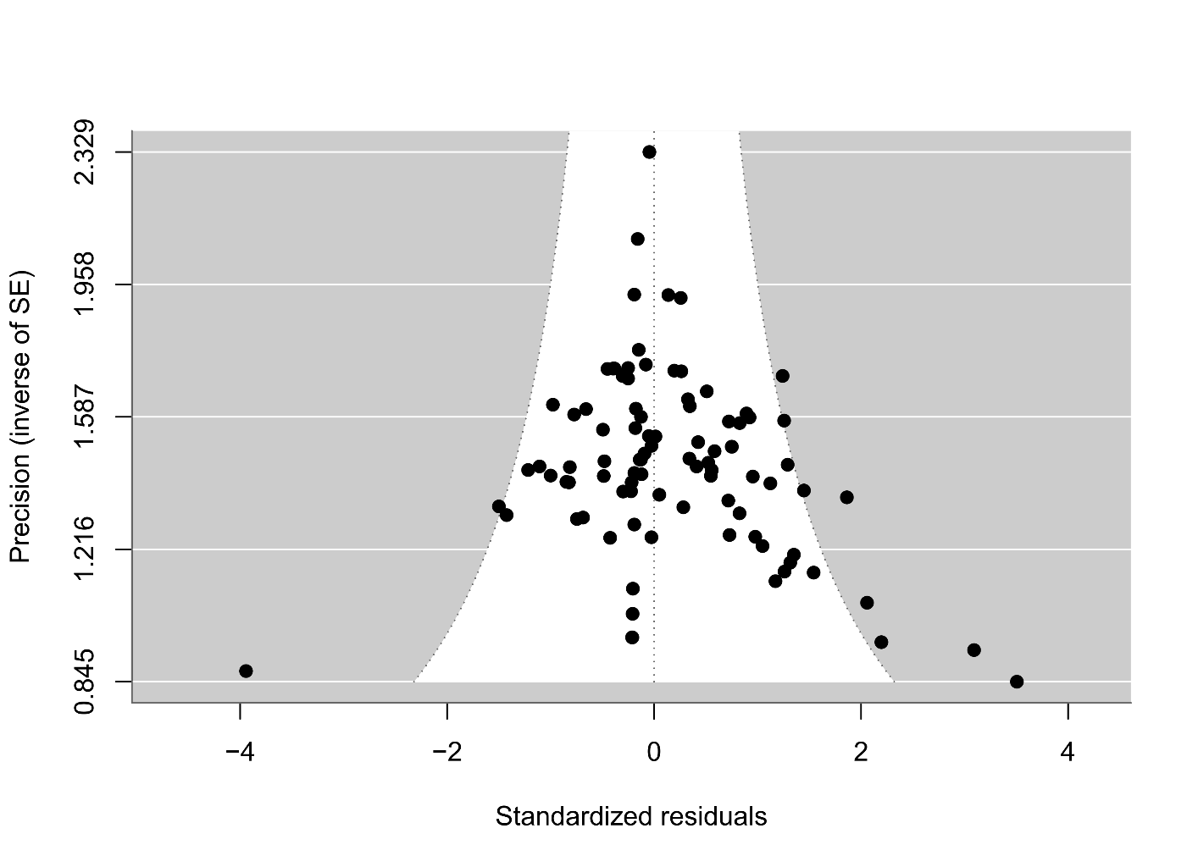
Figure S2.1: Funnel Plot of effect size used to visually assess for publication bias. Each point represents an individual effect size (k = 93), with the precision of the effect size shown on the y axis and the standardized residuals on the x axis. We found no evidence for publication basis in our dataset given the results of our Eggers regression.
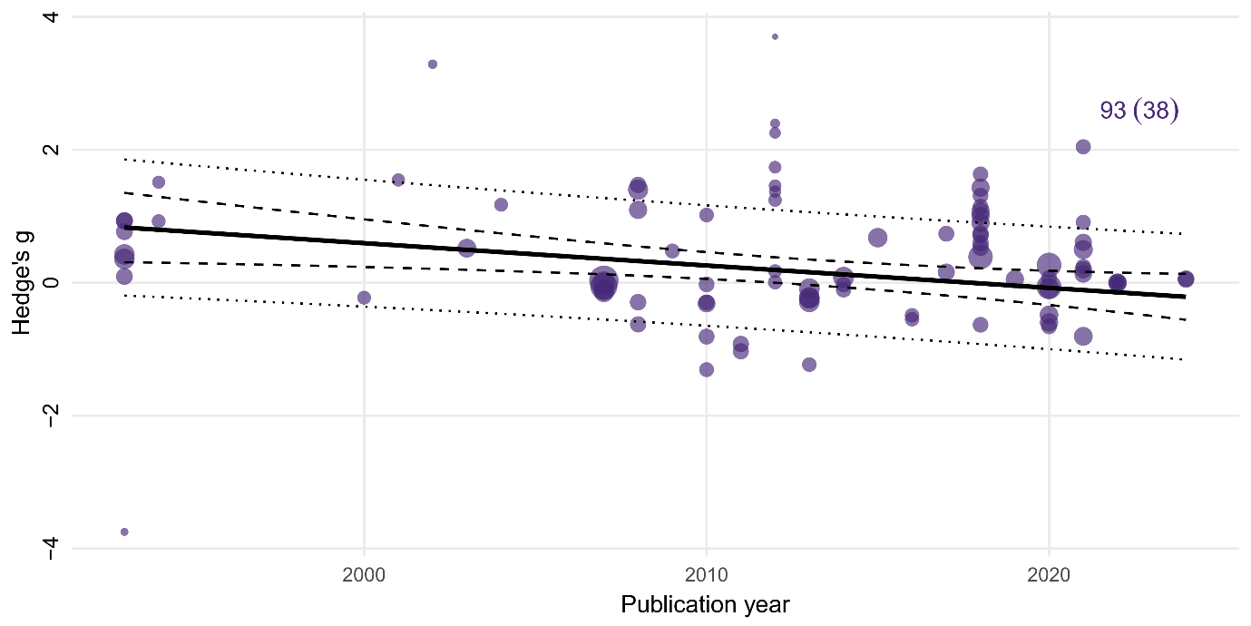
Figure S2.2: Meta-regression of effect sizes against publication year. Each point represents an induvial effect size (k = 93), with the point size scaled by precision. The solid line indicates the estimated regression slope, with the 95% confidence interval shown by the dashed lines. The dotted lines show 95% prediction intervals. We found a significant decline effect in our dataset, with the magnitude of effect sizes declining over time.
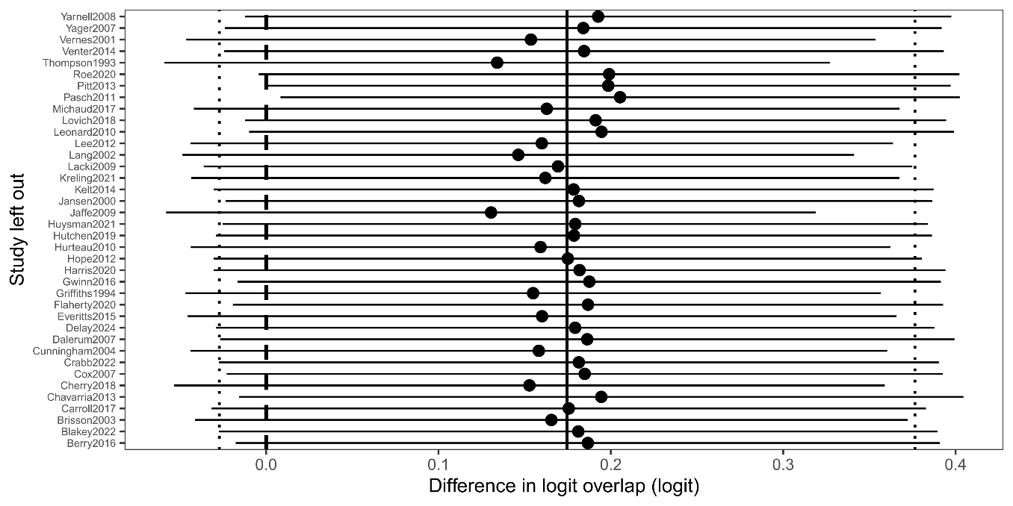
Figure S2.3: Plot of the leave-one-study-out test for the overall random effects model. The y axis shows the study left out, and the x axis the difference in the logit overlap between the pooled overall effect size and the re-estimated pooled effect size with the study excluded. The vertical solid black line shows the overall pooled effect size with all studies included, and the black circles indicate re-estimated pooled effect size with the removal of that study. The dashed vertical lines show the upper and lower 95% confindence limits of the overall pooled effect size. The consistency of the re-estimated pooled effect sizes indicated that no single study had a dissporotionate effect on the outcome of the overall model.

Supplementary Information 3: Dataset Summary
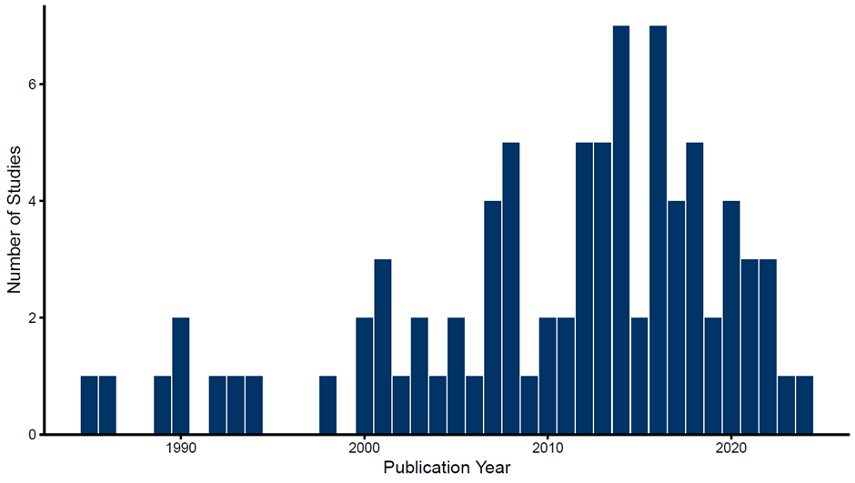
Figure S3.1: Plot showing the distribution of year of publication the studies (n = 84) included in the systematic review and meta-analysis investigating the influence of fire on animal movement. The number of studies published is shown on the y axis, and the year of publication on the x axis.

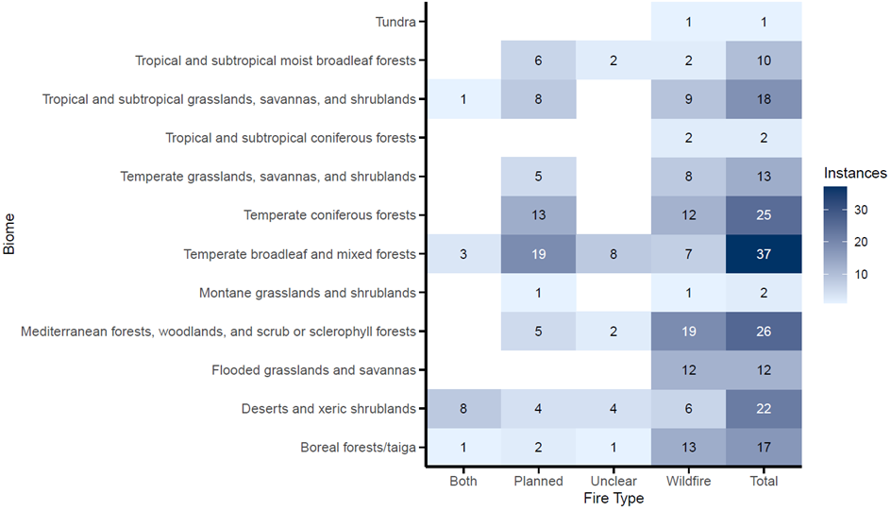
Figure S3.2: Plot showing the number of cases (n = 185) included in the systematic review and meta-analysis investigating the influence of fire on animal movement for each combination of fire type and terrestrial biome. The y axis displays biome (Olson et al., 2001), with fire type displayed on the x axis.

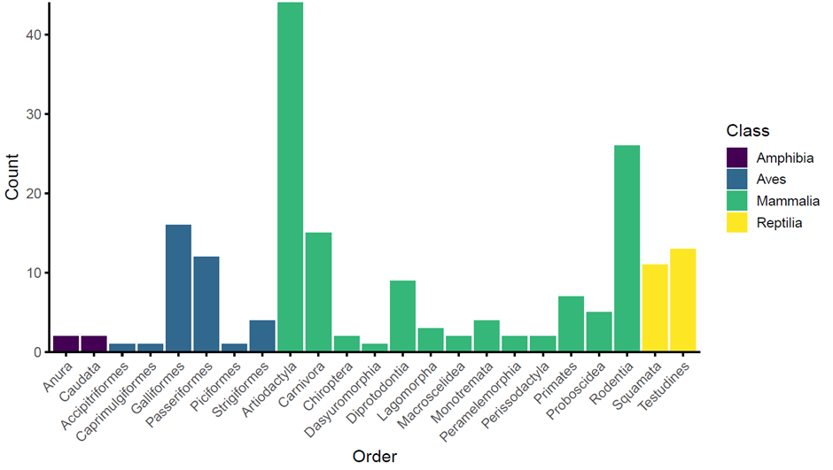
Figure S3.3: Plot showing the taxonomic orders and classes included in the systematic review and meta-analysis investigating the influence of fire on animal movement, and the number of cases (n = 185) by order. Counts of cases are shown on the y axis, and orders, arranged by class, are shown on the x axis.

Supplementary Information 4: Meta-analysis
Table S4.1: Outputs of the models exploring the influence of fire on the movement of terrestrial animals. Estimated effect size (Hedge’s g), standard error, t-value, p-value, degrees of freedom, and upper and lower 95% confidence intervals are provided. Significant estimates (p < 0.05) are indicated in bold font.
Term | Estimate | Standard Error | t-value | df | P-value | Lower 95% CI | Upper 95% CI
Overall Movement Response
intrcpt | 0.175 | 0.102 | 1.719 | 92.000 | 0.089 | -0.027 | 0.376
Movement Category
Movement_categoryHome Range | 0.123 | 0.110 | 1.117 | 90.000 | 0.267 | -0.096 | 0.343
Movement_categoryLinear Distance | 0.271 | 0.125 | 2.159 | 90.000 | 0.034 | 0.022 | 0.520
Movement_categoryTortuosity | 0.155 | 0.248 | 0.625 | 90.000 | 0.534 | -0.338 | 0.647
Movement Response by Class
class_ncbiAves | 0.401 | 0.198 | 2.030 | 89.000 | 0.045 | 0.008 | 0.793
class_ncbiMammalia | 0.183 | 0.142 | 1.287 | 89.000 | 0.201 | -0.100 | 0.466
class_ncbiReptilia | 0.002 | 0.212 | 0.009 | 89.000 | 0.993 | -0.419 | 0.422
Impact Fire Type
intrcpt | 0.147 | 0.160 | 0.919 | 75.000 | 0.361 | -0.172 | 0.467
Impact_fire_typeWildfire | 0.075 | 0.221 | 0.340 | 75.000 | 0.735 | -0.366 | 0.516
Fire Size
intrcpt | -0.21 | 0.38 | -0.55 | 60 | 0.59 | -0.96 | 0.55
log.size | 0.05 | 0.04 | 1.07 | 60 | 0.29 | -0.04 | 0.13
Maximum Treatment Age
intrcpt | 0.514 | 0.379 | 1.355 | 89.000 | 0.179 | -0.239 | 1.267
log.age | -0.052 | 0.061 | -0.861 | 89.000 | 0.391 | -0.173 | 0.069
Biome
Deserts and xeric shrublands | -0.685 | 0.363 | -1.887 | 64.000 | 0.064 | -1.410 | 0.040
Flooded grasslands and savannas | 0.304 | 0.471 | 0.646 | 64.000 | 0.521 | -0.636 | 1.244
Mediterranean forests, woodlands, and scrub or sclerophyll forests | -0.227 | 0.387 | -0.587 | 64.000 | 0.559 | -1.000 | 0.546
Temperate broadleaf and mixed forests | 0.147 | 0.306 | 0.482 | 64.000 | 0.631 | -0.463 | 0.758
Temperate coniferous forests | -0.149 | 0.330 | -0.451 | 64.000 | 0.654 | -0.808 | 0.510
Body Mass
intrcpt | 0.171 | 0.279 | 0.615 | 91.000 | 0.540 | -0.382 | 0.725
logmass | 0.001 | 0.037 | 0.015 | 91.000 | 0.988 | -0.072 | 0.073
Mammalia Body Mass
intrcpt | -0.115 | 0.436 | -0.264 | 56.000 | 0.793 | -0.988 | 0.758
logmass | 0.035 | 0.050 | 0.706 | 56.000 | 0.483 | -0.064 | 0.135
Aves Body Mass
intrcpt | 0.148 | 1.340 | 0.111 | 18.000 | 0.913 | -2.666 | 2.962
logmass | 0.041 | 0.140 | 0.295 | 18.000 | 0.771 | -0.253 | 0.335
Reptilia Body Mass
intrcpt | 1.027 | 0.627 | 1.639 | 12.000 | 0.127 | -0.339 | 2.393
logmass | -0.145 | 0.088 | -1.658 | 12.000 | 0.123 | -0.336 | 0.046
Decline Effect
intrcpt | 67.856 | 24.823 | 2.734 | 91.000 | 0.008 | 18.548 | 117.164
Publication_Year | -0.034 | 0.012 | -2.727 | 91.000 | 0.008 | -0.058 | -0.009
Egger's Effect
intrcpt | 0.235 | 0.210 | 1.122 | 91.000 | 0.265 | -0.181 | 0.652
sqeffectN | -0.022 | 0.068 | -0.327 | 91.000 | 0.745 | -0.158 | 0.113

estimate | se | tval | df | pval | ci.lb | ci.ub
0.183 | 0.269 | 0.678 | 81.000 | 0.500 | -0.354 | 0.719 | veg_climateclosed_Cold
-0.006 | 0.209 | -0.028 | 81.000 | 0.978 | -0.421 | 0.410 | veg_climateclosed_Temperate
-0.200 | 0.252 | -0.793 | 81.000 | 0.430 | -0.700 | 0.301 | veg_climateopen_Arid
0.808 | 0.389 | 2.075 | 81.000 | 0.041 | 0.033 | 1.582 | veg_climateopen_Tropical
-0.091 | 0.202 | -0.450 | 89.000 | 0.654 | -0.493 | 0.311 | ClimateArid
0.225 | 0.245 | 0.915 | 89.000 | 0.362 | -0.263 | 0.712 | ClimateCold
0.208 | 0.141 | 1.481 | 89.000 | 0.142 | -0.071 | 0.488 | ClimateTemperate
0.865 | 0.412 | 2.101 | 89.000 | 0.038 | 0.047 | 1.683 | ClimateTropical

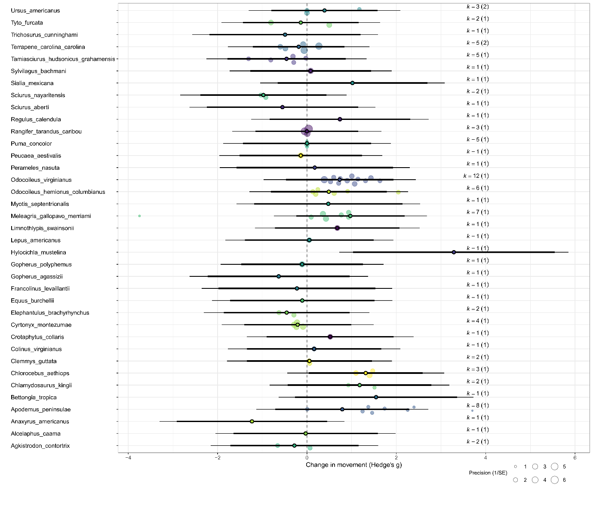
Figure S4.1: Plot showing mean and individual effect sizes for all species included in the meta-analysis investigating the influence of fire on animal movement. Species are shown on the y axis and Hedge’s g on the x axis. Mean effect sizes (for species with at least two effect sizes) and individual effect sizes are shown by the outlined coloured circles. Coloured circles without an outline show the effect sizes used to calculate mean effect sizes. The thick horizontal lines represent the upper and lower 95% confidence intervals. K is the number of effect sizes calculated for each species and the number in the parentheses indicates how many studies the effect sizes were drawn from.

Supplementary Information 5: PRISMA-EcoEvo Checklist
Table S5.1: PRISMA Eco-Evo checklist for preferred reporting for meta-analysis in ecology and evolution. From O'Dea et al. (2021).

Checklist item | Sub-item number | Sub-item | Reported by authors? | Notes
Title and abstract | 1.1 | Identify the review as a systematic review, meta-analysis, or both | Yes
 | 1.2 | Summarize the aims and scope of the review | Yes
 | 1.3 | Describe the data set | Yes
 | 1.4 | State the results of the primary outcome | Yes
 | 1.5 | State conclusions | Yes
 | 1.6 | State limitations | Yes
Aims and questions | 2.1 | Provide a rationale for the review | Yes
 | 2.2 | Reference any previous reviews or meta-analyses on the topic | Yes
 | 2.3 | State the aims and scope of the review (including its generality) | Yes
 | 2.4 | State the primary questions the review addresses (e.g., which moderators were tested) | Yes
 | 2.5 | Describe whether effect sizes were derived from experimental and/or observational comparisons | Yes
Review registration | 3.1 | Register review aims, hypotheses (if applicable), and methods in a time-stamped and publicly accessible archive and provide a link to the registration in the methods section of the manuscript. Ideally registration occurs before the search, but it can be done at any stage before data analysis. | No
 | 3.2 | Describe deviations from the registered aims and methods | N/A
 | 3.3 | Justify deviations from the registered aims and methods | N/A
Eligibility criteria | 4.1 | Report the specific criteria used for including or excluding studies when screening titles and/or abstracts, and full texts, according to the aims of the systematic review (e.g., study design, taxa, data availability) | Yes
 | 4.2 | Justify criteria, if necessary (i.e., not obvious from aims and scope) | Yes
Finding studies | 5.1 | Define the type of search (e.g., comprehensive search, representative sample) | Yes
 | 5.2 | State what sources of information were sought (e.g., published and unpublished studies, personal communications) | Yes
 | 5.3 | Include, for each database searched, the exact search strings used, with keyword combinations and Boolean operators | Yes
 | 5.4 | Provide enough information to repeat the equivalent search (if possible), including the timespan covered (start and end dates) | Yes
Study selection | 6.1 | Describe how studies were selected for inclusion at each stage of the screening process (e.g., use of decision trees, screening software) | Yes
 | 6.2 | Report the number of people involved and how they contributed (e.g., independent parallel screening) | Yes
Data collection process | 7.1 | Describe where in the reports data were collected from (e.g., text or figures) | Yes
 | 7.2 | Describe how data were collected (e.g., software used to digitize figures, external data sources) | Yes
 | 7.3 | Describe moderator variables that were constructed from collected data (e.g., number of generations calculated from years and average generation time) | Yes
 | 7.4 | Report how missing or ambiguous information was dealt with during data collection (e.g., authors of original studies were contacted for missing descriptive statistics, and/or effect sizes were calculated from test statistics) | Yes
Data items | 8.1 | Describe the key data sought from each study | Yes
 | 8.2 | Describe items that do not appear in the main results, or which could not be extracted due to insufficient information | Yes
 | 8.3 | Describe main assumptions or simplifications that were made (e.g., categorizing both ‘length’ and ‘mass’ as ‘morphology’) | Yes
 | 8.4 | Describe the type of replication unit (e.g., individuals, broods, study sites) | Yes
Assessment of individual study quality | 9.1 | Describe whether the quality of studies included in the systematic review or meta-analysis was assessed (e.g., blinded data collection, reporting quality, experimental versus observational) | Yes
 | 9.2 | Describe how information about study quality was incorporated into analyses (e.g., meta-regression and/or sensitivity analysis) | Yes
Effect size measures | 10.1 | Describe effect size(s) used | Yes
 | 10.2 | Provide a reference to the equation of each calculated effect size (e.g., standardized mean difference, log response ratio) and (if applicable) its sampling variance | Yes
 | 10.3 | If no reference exists, derive the equations for each effect size and state the assumed sampling distribution(s) | N/A
Missing data | 11.1 | Describe any steps taken to deal with missing data during analysis (e.g., imputation, complete case, subset analysis) | Yes
 | 11.2 | Justify the decisions made to deal with missing data | N/A
Meta-analytic model description | 12.1 | Describe the models used for synthesis of effect sizes | Yes
 | 12.2 | The most common approach in ecology and evolution will be a random-effects model, often with a hierarchical/multilevel structure. If other types of models are chosen (e.g., common/fixed effects model, unweighted model), provide justification for this choice | N/A
Software | 13.1 | Describe the statistical platform used for inference (e.g., R) | Yes
 | 13.2 | Describe the packages used to run models | Yes
 | 13.3 | Describe the functions used to run models | Yes
 | 13.4 | Describe any arguments that differed from the default settings | Yes
 | 13.5 | Describe the version numbers of all software used | Yes
Non-independence | 14.1 | Describe the types of non-independence encountered (e.g., phylogenetic, spatial, multiple measurements over time) | Yes
 | 14.2 | Describe how non-independence has been handled | Yes
 | 14.3 | Justify decisions made | Yes
Meta-regression and model selection | 15.1 | Provide a rationale for the inclusion of moderators (covariates) that were evaluated in meta-regression models | Yes
 | 15.2 | Justify the number of parameters estimated in models, in relation to the number of effect sizes and studies (e.g., interaction terms were not included due to insufficient sample sizes) | Yes
 | 15.3 | Describe any process of model selection | N/A
Publication bias and sensitivity analyses | 16.1 | Describe assessments of the risk of bias due to missing results (e.g., publication, time-lag, and taxonomic biases) | Yes
 | 16.2 | Describe any steps taken to investigate the effects of such biases (if present) | Yes
 | 16.3 | Describe any other analyses of robustness of the results, e.g., due to effect size choice, weighting or analytical model assumptions, inclusion or exclusion of subsets of the data, or the inclusion of alternative moderator variables in meta-regressions | N/A
Clarification of post hoc analyses | 17.1 | When hypotheses were formulated after data analysis, this should be acknowledged. | N/A
Metadata, data, and code | 18.1 | Share metadata (i.e., data descriptions) | Yes
 | 18.2 | Share data required to reproduce the results presented in the manuscript | Yes
 | 18.3 | Share additional data, including information that was not presented in the manuscript (e.g., raw data used to calculate effect sizes, descriptions of where data were located in papers) | Yes
 | 18.4 | Share analysis scripts (or, if a software package with graphical user interface (GUI) was used, then describe full model specification and fully specify choices) | Yes
Results of study selection process | 19.1 | Report the number of studies screened | Yes
 | 19.2 | Report the number of studies excluded at each stage of screening | Yes
 | 19.3 | Report brief reasons for exclusion from the full text stage | Yes
 | 19.4 | Present a Preferred Reporting Items for Systematic Reviews and Meta-Analyses (PRISMA)-like flowchart (www.prisma-statement.org). | Yes
Sample sizes and study characteristics | 20.1 | Report the number of studies and effect sizes for data included in meta-analyses | Yes
 | 20.2 | Report the number of studies and effect sizes for subsets of data included in meta-regressions | Yes
 | 20.3 | Provide a summary of key characteristics for reported outcomes (either in text or figures, e.g., one quarter of effect sizes reported for vertebrates and the rest invertebrates) | Yes
 | 20.4 | Provide a summary of limitations of included moderators (e.g., collinearity and overlap between moderators) | Yes
 | 20.5 | Provide a summary of characteristics related to individual study quality (risk of bias) | Yes
Meta-analysis | 21.1 | Provide a quantitative synthesis of results across studies, including estimates for the mean effect size, with confidence/credible intervals | Yes
Heterogeneity | 22.1 | Report indicators of heterogeneity in the estimated effect (e.g., I², tau² and other variance components) | Yes
Meta-regression | 23.1 | Provide estimates of meta-regression slopes (i.e., regression coefficients) and confidence/credible intervals | Yes
 | 23.2 | Include estimates and confidence/credible intervals for all moderator variables that were assessed (i.e., complete reporting) | Yes
 | 23.3 | Report interactions if they were included | Yes
 | 23.4 | Describe outcomes from model selection, if done (e.g., R2 and AIC) | N/A
Outcomes of publication bias and sensitivity analyses | 24.1 | Provide results for the assessments of the risks of bias (e.g., Egger's regression, funnel plots) | Yes
 | 24.2 | Provide results for the robustness of the review's results (e.g., subgroup analyses, meta-regression of study quality, results from alternative methods of analysis, and temporal trends) | Yes | We include decline effect testing, funnel plots and leave one out analysis.
Discussion | 25.1 | Summarize the main findings in terms of the magnitude of effect | Yes
 | 25.2 | Summarize the main findings in terms of the precision of effects (e.g., size of confidence intervals, statistical significance) | Yes
 | 25.3 | Summarize the main findings in terms of their heterogeneity | Yes
 | 25.4 | Summarize the main findings in terms of their biological/practical relevance | Yes
 | 25.5 | Compare results with previous reviews on the topic, if available | Yes
 | 25.6 | Consider limitations and their influence on the generality of conclusions, such as gaps in the available evidence (e.g., taxonomic and geographical research biases) | Yes
Contributions and funding | 26.1 | Provide names, affiliations, and funding sources of all co-authors | Yes
 | 26.2 | List the contributions of each co-author | Yes
 | 26.3 | Provide contact details for the corresponding author | Yes
 | 26.4 | Disclose any conflicts of interest | Yes
References | 27.1 | Provide a reference list of all studies included in the systematic review or meta-analysis | Yes
 | 27.2 | List included studies as referenced sources (e.g., rather than listing them in a table or supplement) | Yes

References
Alves, M. B. (2018). Roe deer's spatio-temporal response to novel environments [Master's, Universidade de Aveiro]. Portugal. https://www.proquest.com/dissertations-theses/roe-deers-spatio-temporal-response-novel/docview/3059437544/se-2?accountid=10344
Ballard, W. B., Krausman, P. R., Boe, S., Cunningham, S., & Whitlaw, H. A. (2000). Short-term response of Gray Wolves, Canis lupis, to wildfire in Northwestern Alaska. Canadian Field-Naturalist, 114(2), 241-247.
Berenstain, L. (1986). Responses of long-tailed macaques to drought and fire in eastern Borneo - A preliminary-report. Biotropica, 18(3), 257-262. https://doi.org/10.2307/2388494
Berry, L. E., Lindenmayer, D. B., Dennis, T. E., Driscoll, D. A., & Banks, S. C. (2016). Fire severity alters spatio–temporal movements and habitat utilisation by an arboreal marsupial, the mountain brushtail possum (Trichosurus cunninghami). International Journal of Wildland Fire, 25(12), 1291-1302.
Blakey, R. V., Sikich, J. A., Blumstein, D. T., & Riley, S. P. D. (2022). Mountain lions avoid burned areas and increase risky behavior after wildfire in a fragmented urban landscape. Current Biology, 32(21), 4762-4768.e4765. https://doi.org/10.1016/j.cub.2022.08.082
Blanchard, B. M., & Knight, R. R. (1990). Reactions of grizzly bears, Ursus arctos horribilis, to wildfire in Yellowstone National Park, Wyoming. Canadian Field Naturalist, 104(4), 592-594.
Blount, S. J., & Koprowski, J. L. (2012). Response of the Mount Graham red squirrel (Tamiasciurus hudsonicus grahamensis) to postfire conditions. Southwestern Naturalist, 57(1), 8-15. https://doi.org/10.1894/0038-4909-57.1.8
Brisson, J. A., Strasburg, J. L., & Templeton, A. R. (2003). Impact of fire management on the ecology of collared lizard (Crotaphytus collaris) populations living on the Ozark Plateau. Animal Conservation, 6(3), 247-254. https://doi.org/10.1017/S1367943003003305
Carey, A. B., Horton, S. P., & Biswell, B. L. (1992). Northern spotted owls - Influence of prey base and landscape character. Ecological Monographs, 62(2), 223-250. https://doi.org/10.2307/2937094
Carroll, J. M., Davis, C. A., Elmore, R. D., & Fuhlendorf, S. D. (2017). Response of northern bobwhite movements to management-driven disturbance in a shrub-dominated ecosystem. Rangeland Ecology & Management, 70(2), 175-182. https://doi.org/10.1016/j.rama.2016.08.006
Carver, A. V. (1998). Northern bobwhite brood habitat relationships in old-field vegetation in the Red Hills region of northern Florida [Master's, Mississippi State University]. United States of America. https://www.proquest.com/dissertations-theses/northern-bobwhite-brood-habitat-relationships-old/docview/304444408/se-2?accountid=10344
Chavarria, P. M. (2013). Ecology of Montezuma quail in southeast Arizona [Ph.D., Texas A&M University]. United States of America. https://www.proquest.com/dissertations-theses/ecology-montezuma-quail-southeast-arizona/docview/1428165082/se-2?accountid=10344
Cherry, M. J., Chandler, R. B., Garrison, E. P., Crawford, D. A., Kelly, B. D., Shindle, D. B., Godsea, K. G., Miller, K. V., & Conner, L. M. (2018). Wildfire affects space use and movement of white-tailed deer in a tropical pyric landscape. Forest Ecology and Management, 409, 161-169. https://doi.org/10.1016/j.foreco.2017.11.007
Cheyne, S. M., Capilla, B. R., Abdulaziz, K., Supiansyah, Adul, Cahyaningrum, E., & Smith, D. E. (2019). Home range variation and site fidelity of Bornean southern gibbons [Hylobates albibarbis] from 2010-2018. PLoS ONE, 14(7). https://doi.org/10.1371/journal.pone.0217784
Clapp, J. G., & Beck, J. L. (2016). Short-term impacts of fire-mediated habitat alterations on an isolated bighorn sheep population. Fire Ecology, 12(3), 80-98. https://doi.org/10.4996/fireecology.1203080
Cox, J. A., & Jones, C. D. (2007). Home range and survival characteristics of male Bachman's Sparrows in an old-growth forest managed with breeding season burns. Journal of Field Ornithology, 78(3), 263-269. https://doi.org/10.1111/j.1557-9263.2007.00113.x
Crabb, M. L., Clement, M. J., Jones, A. S., Bristow, K. D., & Harding, L. E. (2022). Black bear spatial responses to the Wallow Wildfire in Arizona. Journal of Wildlife Management, 86(3). https://doi.org/10.1002/jwmg.22182
Cross, M. D., Root, K. V., Mehne, C. J., McGowan-Stinski, J., Pearsall, D., & Gillingham, J. C. (2015). Multi-scale responses of eastern massasauga rattlesnakes (Sistrurus catenatus) to prescribed fire. American Midland Naturalist, 173(2), 346-362. https://doi.org/10.1674/amid-173-02-346-362.1
Cunningham, S. C., & Ballard, W. B. (2004). Effects of wildfire on black bear demographics in central Arizona. Wildlife Society Bulletin, 32(3), 928-937. https://doi.org/10.2193/0091-7648(2004)032[0928:EOWOBB]2.0.CO;2
Dalerum, F., Boutin, S., & Dunford, J. S. (2007). Wildfire effects on home range size and fidelity of boreal caribou in Alberta, Canada. Canadian Journal of Zoology, 85(1), 26-32. https://doi.org/10.1139/Z06-186
Delay, S. J., Urquhart, O., & Litzgus, J. D. (2024). Wind farm and wildfire: spatial ecology of an endangered freshwater turtle in a recovering landscape. Canadian Journal of Zoology, 102(2), 124-145. https://doi.org/10.1139/cjz-2023-0100
Everitts, J. L., Benson, T. J., Bednarz, J. C., & Anich, N. M. (2015). Effects of prescribed burning on swainson's warbler home-range size and habitat use. Wildlife Society Bulletin, 39(2), 292-300. https://doi.org/10.1002/wsb.536
Faurby, S., Davis, M., Pedersen, R. Ø., Schowanek, S. D., Antonelli, A., & Svenning, J.-C. (2018). PHYLACINE 1.2: The phylogenetic atlas of mammal macroecology. Ecology, 99(11), 2626-2626. https://doi.org/10.1002/ecy.2443
Flaherty, J. P., & Gienger, C. M. (2020). Habitat selection and movement patterns of copperheads (Agkistrodon contortrix) in fire-altered landscapes. Herpetological Conservation and Biology, 15(1), 150-159.
Fordyce, A., Hradsky, B. A., Ritchie, E. G., & Di Stefano, J. (2016). Fire affects microhabitat selection, movement patterns, and body condition of an Australian rodent (Rattus fuscipes). Journal of Mammalogy, 97(1), 102-111. https://doi.org/10.1093/jmammal/gyv159
Gasaway, W. C., & Dubois, S. D. (1985). Initial response of moose, Alces alces, to wildfire in interior Alaska. Canadian Field-Naturalist, 99(2), 135-140.
Gasaway, W. C., Dubois, S. D., Boertje, R. D., Reed, D. J., & Simpson, D. T. (1989). Response of radio-collared moose to a large burn in central Alaska. Canadian Journal of Zoology, 67(2), 325-329. https://doi.org/10.1139/z89-047
Gonzembach, H., Wolverton, H., & Anderson, R. (2022). Ba-Ba-Bachman's: A note on song production in juvenile Bachman's sparrows (Peucaea aestivalis). Florida Field Naturalist, 50(3), 70–81.
Grahmann, E. D. (2013). Patch-burning and grazing to improve exotic grass-dominated landscapes for northern bobwhites [Ph.D., Texas A&M University]. United States of Americia. https://www.proquest.com/dissertations-theses/patch-burning-grazing-improve-exotic-grass/docview/1972895726/se-2?accountid=10344
Green, K. (2005). Winter home range and foraging of common wombats (Vombatus ursinus) in patchily burnt subalpine areas of the Snowy Mountains, Australia. Wildlife Research, 32(6), 525-529. https://doi.org/10.1071/WR04079
Griffiths, A. D. (1994). The effect of seasonal environment and fire on the ecology of frillneck lizards, Chlamydosaurus kingii, in the wet-dry tropics of northern Australia [Master's, Charles Darwin University]. Australia. https://www.proquest.com/dissertations-theses/effect-seasonal-environment-fire-on-ecology/docview/2606878779/se-2?accountid=10344
Gwinn, R. N., & Koprowski, J. L. (2016). Differential response to fire by an introduced and an endemic species complicates endangered species conservation. Hystrix-Italian Journal of Mammalogy, 27(2). https://doi.org/10.4404/hystrix-27.2-11447
Harris, K. A., Clark, J. D., Elmore, R. D., & Harper, C. A. (2020). Direct and indirect effects of fire on eastern box turtles. Journal of Wildlife Management, 84(7), 1384-1395. https://doi.org/10.1002/jwmg.21920
Herzog, N. M., Parker, C. H., Keefe, E. R., Coxworth, J., Barrett, A., & Hawkes, K. (2014). Fire and home range expansion: A behavioral response to burning among savanna dwelling vervet monkeys (Chlorocebus aethiops). American Journal of Physical Anthropology, 154(4), 554-560. https://doi.org/10.1002/ajpa.22550
Hoffmann, A., & Klingel, H. (2001). Spatial and temporal patterns in Lemniscomys striatus (Linnaeus 1758) as revealed by radio-tracking. African Journal of Ecology, 39(4), 351-356. https://doi.org/10.1046/j.1365-2028.2001.00323.x
Hope, B. (2012). Short-term response of the long-nosed bandicoot, Perameles nasuta, and the southern brown bandicoot, Isoodon obesulus obesulus, to low-intensity prescribed fire in heathland vegetation. Wildlife Research, 39(8), 731-744. https://doi.org/10.1071/WR12110
Howey, C. A. F., Dickinson, M. B., & Roosenburg, W. M. (2016). Effects of a landscape disturbance on the habitat use and behavior of the black racer. Copiea, 104(4), 853-863. https://doi.org/10.1643/CE-15-373
Hurteau, S., Sisk, T., Dickson, B. G., & Block, W. (2010). Variability in nest density, occupancy, and home range size of western bluebirds after forest treatments. Forest Science, 56(1), 131-138. https://doi.org/10.1093/forestscience/56.1.131
Hutchen, J., & Hodges, K. E. (2019). Foraging behaviour of snowshoe hares (Lepus americanus) in conifer forests regenerating after fire. Canadian Journal of Zoology, 97(5), 446-452. https://doi.org/10.1139/cjz-2018-0222
Huysman, A. E., & Johnson, M. D. (2021). Habitat selection by a predator of rodent pests is resilient to wildfire in a vineyard agroecosystem. Ecology and Evolution, 11(24), 18216-18228. https://doi.org/10.1002/ece3.8416
Jaffe, K. E., & Isbell, L. A. (2009). After the fire: Benefits of reduced ground cover for vervet monkeys (Cercopithecus aethiops). American Journal of Primatology, 71(3), 252-260. https://doi.org/10.1002/ajp.20644
Jansen, R., Little, R. M., & Crowe, T. M. (2000). Habitat utilization and home range of the redwing francolin, Francolinus levaillantii, in highland grasslands, Mpumalanga province, South Africa. African Journal of Ecology, 38(4), 329-338. https://doi.org/10.1046/j.1365-2028.2000.00256.x
Johnson, J. B., Mark Ford, W., & Edwards, J. W. (2012). Roost networks of northern myotis (Myotis septentrionalis) in a managed landscape. Forest Ecology and Management, 266, 223-231. https://doi.org/10.1016/j.foreco.2011.11.032
Jones, C. D., Cox, J. A., & Cooper, R. J. (2014). Bachman's sparrow (Peucaea aestivalis) response to variation in the extent of burns conducted during the nesting season. Avian Conservation and Ecology, 9(1). https://doi.org/10.5751/ACE-00632-090103
Kelt, D. A., Kelly, P. A., Phillips, S. E., & Williams, D. F. (2014). Home range size and habitat selection of reintroduced Sylvilagus bachmani riparius. Journal of Mammalogy, 95(3), 516-524. https://doi.org/10.1644/13-MAMM-A-187
Körtner, G., Pavey, C. R., & Geiser, F. (2007). Spatial ecology of the mulgara in arid Australia: Impact of fire history on home range size and burrow use. Journal of Zoology, 273(4), 350-357. https://doi.org/10.1111/j.1469-7998.2007.00334.x
Kreling, S. E. S., Gaynor, K. M., McInturff, A., Calhoun, K. L., & Brashares, J. S. (2021). Site fidelity and behavioral plasticity regulate an ungulate's response to extreme disturbance. Ecology and Evolution, 11(22), 15683-15694. https://doi.org/10.1002/ece3.8221
Lacki, M. J., Cox, D. R., Dodd, L. E., & Dickinson, M. B. (2009). Response of northern bats (Myotisseptentrionalis) to prescribed fires in eastern Kentucky forests. Journal of Mammalogy, 90(5), 1165-1175. https://doi.org/10.1644/08-MAMM-A-349.1
Lang, J. D., Powell, L. A., Krementz, D. G., & Conroy, M. J. (2002). Wood thrush movements and habitat use: Effects of forest management for red-cockaded woodpeckers. Auk, 119(1), 109-124. https://doi.org/10.1642/0004-8038(2002)119[0109:WTMAHU]2.0.CO;2
Lappan, S., Sibarani, M., O'Brien, T. G., Nurcahyo, A., Andayani, N., Rustiati, E. L., Surya, R. A., & Morino, L. (2021). Long-term effects of forest fire on habitat use by siamangs in Southern Sumatra. Animal Conservation, 24(3), 355-366. https://doi.org/10.1111/acv.12640
Law, B., Chidel, M., Britton, A., & Brassil, T. (2013). Response of eastern pygmy possums, Cercartetus nanus, to selective logging in New South Wales: Home range, habitat selection and den use. Wildlife Research, 40(6), 470-481. https://doi.org/10.1071/WR13105
Lee, E. J., Rhim, S. J., & Lee, W. S. (2012). Seasonal movements and home range sizes of korean field mouse Apodemus peninsulae in unburned and post-fire pine planted stands within a pine forest. Journal of Animal and Veterinary Advances, 11(20), 3834-3839. https://doi.org/10.3923/javaa.2012.3834.3839
Leonard, K. M., & Koprowski, J. L. (2010). Effects of fire on endangered mount graham red squirrels (Tamiasciurus hudsonicus grahamensis): Responses of individuals with known fates. Southwestern Naturalist, 55(2), 217-224. https://doi.org/10.1894/MRD-01.1
Lindenmayer, D. B., MacGregor, C., Welsh, A., Donnelly, C. F., & Brown, D. (2008). The use of hollows and dreys by the common ringtail possum (Pseudocheirus peregrinus) in different vegetation types. Australian Journal of Zoology, 56(1), 1-11. https://doi.org/10.1071/ZO08054
Lovich, J. E., Agha, M., Ennen, J. R., Arundel, T. R., & Austin, M. (2018). Agassiz's desert tortoise (Gopherus agassizii) activity areas are little changed after wind turbine-induced fires in California. International Journal of Wildland Fire, 27(12), 851-856. https://doi.org/10.1071/WF18147
MacGregor, C. I., Wood, J. T., Dexter, N., & Lindenmayer, D. B. (2013). Home range size and use by the long-nosed bandicoot (Perameles nasuta) following fire. Australian Mammalogy, 35(2), 206-216. https://doi.org/10.1071/AM12032
McGregor, H. W., Legge, S., Jones, M. E., & Johnson, C. N. (2014). Landscape management of fire and grazing regimes alters the fine-scale habitat utilisation by feral cats. PLoS ONE, 9(10), e109097. https://doi.org/10.1371/journal.pone.0109097
Michael, D. R., Cunningham, R. B., Macgregor, C., Brown, D., & Lindenmayer, D. B. (2014). The effects of prey, habitat heterogeneity and fire on the spatial ecology of peninsular Diamond Pythons (Morelia spilota spilota: Pythonidae). Austral Ecology, 39(2), 181-189. https://doi.org/10.1111/aec.12056
Michaud, J. M. (2017). Habitat use by wintering passerines in fire-managed forests along the U.S. Gulf Coast [Master's, Eastern Kentucky University]. United States of America. https://www.proquest.com/dissertations-theses/habitat-use-wintering-passerines-fire-managed/docview/1906305078/se-2?accountid=10344
Morollón, S., Pausas, J. G., Urios, V., & López-López, P. (2022). Wildfire response of GPS-tracked Bonelli's eagles in eastern Spain. International Journal of Wildland Fire, 31(9), 901-908. https://doi.org/10.1071/WF22018
Nowack, J., Cooper, C. E., & Geiser, F. (2016). Cool echidnas survive the fire. Proceedings of The Royal Society B-Biological Sciences, 283(1828). https://doi.org/10.1098/rspb.2016.0382
O'Dea, R. E., Lagisz, M., Jennions, M. D., Koricheva, J., Noble, D. W. A., Parker, T. H., Gurevitch, J., Page, M. J., Stewart, G., Moher, D., & Nakagawa, S. (2021). Preferred reporting items for systematic reviews and meta-analyses in ecology and evolutionary biology: A PRISMA extension. Biological Reviews, 96(5), 1695-1722. https://doi.org/10.1111/brv.12721
O'Donnell, K. M., Thompson, F. R., & Semlitsch, R. D. (2016). Prescribed fire alters surface activity and movement behavior of a terrestrial salamander. Journal of Zoology, 298(4), 303-309. https://doi.org/10.1111/jzo.12316
Odden, M., Wegge, P., & Storaas, T. (2005). Hog deer Axis porcinus need threatened tallgrass floodplains:: a study of habitat selection in lowland Nepal. Animal Conservation, 8, 99-104. https://doi.org/10.1017/S1367943004001854
Oliveira, B. F., São-Pedro, V. A., Santos-Barrera, G., Penone, C., & Costa, G. C. (2017). AmphiBIO, a global database for amphibian ecological traits. Scientific Data, 4(1), 170123. https://doi.org/10.1038/sdata.2017.123
Olson, D. M., Dinerstein, E., Wikramanayake, E. D., Burgess, N. D., Powell, G. V. N., Underwood, E. C., D'Amico, J. A., Itoua, I., Strand, H. E., Morrison, J. C., Loucks, C. J., Allnutt, T. F., Ricketts, T. H., Kura, Y., Lamoreux, J. F., Wettengel, W. W., Hedao, P., & Kassem, K. R. (2001). Terrestrial ecoregions of the world: A new map of life on Earth: A new global map of terrestrial ecoregions provides an innovative tool for conserving biodiversity. Bioscience, 51(11), 933-938. https://doi.org/10.1641/0006-3568(2001)051[0933:TEOTWA]2.0.CO;2
Oskyrko, O. M., Chunrong; Meiri, Shai; Du, Weiguo. (2024). ReptTraits: A comprehensive dataset of ecological traits in reptiles.
Page, M. J., McKenzie, J. E., Bossuyt, P. M., Boutron, I., Hoffmann, T. C., Mulrow, C. D., Shamseer, L., Tetzlaff, J. M., Akl, E. A., Brennan, S. E., Chou, R., Glanville, J., Grimshaw, J. M., Hróbjartsson, A., Lalu, M. M., Li, T., Loder, E. W., Mayo-Wilson, E., McDonald, S., . . . Moher, D. (2021). The PRISMA 2020 statement: An updated guideline for reporting systematic reviews. BMJ, 372, n71. https://doi.org/10.1136/bmj.n71
Pasch, B., & Koprowski, J. L. (2011). Impacts of fire suppression on space use by Mexican fox squirrels. Journal of Mammalogy, 92(1), 227-234. https://doi.org/10.1644/10-MAMM-A-133.1
Pitt, A. L., Tavano, J. J., Baldwin, R. F., & Waldrop, T. A. (2013). Effects of fuel reduction treatments on movement and habitat use of American toads in a southern Appalachian hardwood forest. Forest Ecology and Management, 310, 289-299. https://doi.org/10.1016/j.foreco.2013.08.032
Pople, R. G., & Esquivel, A. (2012). Response of white-winged nightjars Eleothreptus candicans to a prescribed burn of cerrado grassland at Bosque Mbaracayú Biosphere Reserve, Paraguay. Conservation Evidence, 9, 36-42.
Povh, L. F., Willers, N., Shephard, J. M., & Fleming, P. A. (2023). A conservation-significant threatened mammal uses fire exclusions and shifts ranges in the presence of prescribed burning. International Journal of Wildland Fire, 32(9), 1291-1303. https://doi.org/10.1071/WF22196
Rickbeil, G. J. M., Hermosilla, T., Coops, N. C., White, J. C., & Wulder, M. A. (2017). Barren-ground caribou (Rangifer tarandus groenlandicus) behaviour after recent fire events; integrating caribou telemetry data with Landsat fire detection techniques. Global Change Biology, 23(3), 1036-1047. https://doi.org/10.1111/gcb.13456
Roe, J. H., Kish, A. L., & Nacy, J. P. (2020). Variation and repeatability of home range in a forest-dwelling terrestrial turtle: Implications for prescribed fire in forest management. Journal of Zoology, 310(1), 71-82. https://doi.org/10.1111/jzo.12732
Rota, C. T., Rumble, M. A., Millspaugh, J. J., Lehman, C. P., & Kesler, D. C. (2014). Space-use and habitat associations of Black-backed Woodpeckers (Picoides arcticus) occupying recently disturbed forests in the Black Hills, South Dakota. Forest Ecology and Management, 313, 161-168. https://doi.org/10.1016/j.foreco.2013.10.048
Sanz-Aguilar, A., Anadón, J. D., Giménez, A., Ballestar, R., Graciá, E., & Oro, D. (2011). Coexisting with fire: The case of the terrestrial tortoise Testudo graeca in mediterranean shrublands. Biological Conservation, 144(3), 1040-1049. https://doi.org/10.1016/j.biocon.2010.12.023
Shaw, J. H., & Carter, T. S. (1990). Bison movements in relation to fire and seasonality. Wildlife Society Bulletin 18(4), 426-430.
Silva, J. A., Nielsen, S. E., McLoughlin, P. D., Rodgers, A. R., Hague, C., & Boutin, S. (2020). Comparison of pre-fire and post-fire space use reveals varied responses by woodland caribou (Rangifer tarandus caribou) in the boreal shield. Canadian Journal of Zoology, 98(11), 751-760. https://doi.org/10.1139/cjz-2020-0139
Sommer, N. R., Moody, N. M., Lantz, S. M., Leu, M., Karubian, J., & Swaddle, J. P. (2018). Red-backed fairywrens adjust habitat use in response to dry season fires. Austral Ecology, 43(8), 876-889. https://doi.org/10.1111/aec.12629
Sutton, W. B., Wang, Y., Schweitzer, C. J., & McClure, C. J. W. (2017). Spatial ecology and multi-scale habitat selection of the Copperhead (Agkistrodon contortrix) in a managed forest landscape. Forest Ecology and Management, 391, 469-481. https://doi.org/10.1016/j.foreco.2017.02.041
Thompson, C. M., Augustine, D. J., & Mayers, D. M. (2008). Swift fox response to prescribed fire in shortgrass steppe. Western North American Naturalist, 68(2), 251-256. https://doi.org/10.3398/1527-0904(2008)68[251:SFRTPF]2.0.CO;2
Thompson, W. L. (1993). Ecology of Merriam's turkeys in relation to burned and logged areas in southeastern Montana [Ph.D., Montana State University]. United States of America. https://www.proquest.com/dissertations-theses/ecology-merriams-turkeys-relation-burned-logged/docview/304050414/se-2?accountid=10344
Tobias, J. A., Sheard, C., Pigot, A. L., Devenish, A. J. M., Yang, J., Sayol, F., Neate-Clegg, M. H. C., Alioravainen, N., Weeks, T. L., Barber, R. A., Walkden, P. A., MacGregor, H. E. A., Jones, S. E. I., Vincent, C., Phillips, A. G., Marples, N. M., Montaño-Centellas, F. A., Leandro-Silva, V., Claramunt, S., . . . Schleuning, M. (2022). AVONET: morphological, ecological and geographical data for all birds. Ecology Letters, 25(3), 581-597. https://doi.org/https://doi.org/10.1111/ele.13898
Tulloch, A. I., & Dickman, C. R. (2006). Floristic and structural components of habitat use by the eastern pygmy-possum (Cercartetus nanus) in burnt and unburnt habitats. Wildlife Research, 33(8), 627-637. https://doi.org/10.1071/WR06057
Tyers, D. B. (2003). Winter ecology of moose on the Northern Yellowstone Winter Range [Ph.D., Montana State University]. United States of America. https://www.proquest.com/dissertations-theses/winter-ecology-moose-on-northern-yellowstone/docview/305310599/se-2?accountid=10344
VanTassel, H. L. H., & Anderson, K. E. (2018). Altered space use and movement distances of Merriam's kangaroo rat, Dipodomys merriami, in post-fire lands. Journal of Mammalogy, 99(3), 684-692. https://doi.org/10.1093/jmammal/gyy043
Venter, J. A., Nabe-Nielsen, J., Prins, H. H. T., & Slotow, R. (2014). Forage patch use by grazing herbivores in a South African grazing ecosystem. Acta Theriologica, 59(3), 457-466. https://doi.org/10.1007/s13364-014-0184-y
Vernes, K., & Pope, L. C. (2001). Stability of nest range, home range and movement of the northern bettong (Bettongia tropica) following moderate-intensity fire in a tropical woodland, north-eastern Queensland. Wildlife Research, 28(2), 141-150. https://doi.org/10.1071/WR00054
Vernes, K., & Haydon, D. T. (2001). Effect of fire on northern bettong (Bettongia tropica) foraging behaviour. Austral Ecology, 26(6), 649-659. https://doi.org/10.1046/j.1442-9993.2001.01141.x
Winiarski, J. M., Moorman, C. E., & Carpenter, J. P. (2017). Bachman's Sparrows at the northern periphery of their range: home range size and microhabitat selection. Journal of Field Ornithology, 88(3), 250-261. https://doi.org/10.1111/jofo.12215
Woolley, L. A., Millspaugh, J. J., Woods, R. J., van Rensburg, S. J., Mackey, R. L., Page, B., & Slotow, R. (2008). Population and Individual Elephant Response to a Catastrophic Fire in Pilanesberg National Park. PLoS ONE, 3(9). https://doi.org/10.1371/journal.pone.0003233
Yager, L. Y., Hinderliter, M. G., Heise, C. D., & Epperson, D. M. (2007). Gopher tortoise response to habitat management by prescribed burning. Journal Of Wildlife Management, 71(2), 428-434. https://doi.org/10.2193/2006-337
Yarnell, R. W., Metcalfe, D. J., Dunstone, N., Burnside, N., & Scott, D. M. (2008). The impact of fire on habitat use by the short-snouted elephant shrew (Elephantulus brachyrhynchus) in North West Province, South Africa. African Zoology, 43(1), 45-52. https://doi.org/10.1080/15627020.2008.11407405

